Cloud Functions: Qwik Start - Console

15 minutes1 Credit

Rate Lab

**GSP081**



**Overview**

Cloud Functions is a serverless execution environment for building and connecting cloud services. With Cloud Functions you write simple, single-purpose functions that are attached to events emitted from your cloud infrastructure and services. Your Cloud Function is triggered when an event being watched is fired. Your code executes in a fully managed environment. There is no need to provision any infrastructure or worry about managing any servers.

Cloud Functions are written in Javascript and execute in a Node.js environment on Google Cloud. You can take your Cloud Function and run it in any standard Node.js runtime which makes both portability and local testing a breeze.

Connect and Extend Cloud Services

Cloud Functions provides a connective layer of logic that lets you write code to connect and extend cloud services. Listen and respond to a file upload to Cloud Storage, a log change, or an incoming message on a Cloud Pub/Sub topic. Cloud Functions augments existing cloud services and allows you to address an increasing number of use cases with arbitrary programming logic. Cloud Functions have access to the Google Service Account credential and are thus seamlessly authenticated with the majority of Google Cloud services such as Datastore, Cloud Spanner, Cloud Translation API, Cloud Vision API, as well as many others. In addition, Cloud Functions are supported by numerous [Node.js client libraries](https://cloud.google.com/nodejs/apis), which further simplify these integrations.

Events and Triggers

Cloud events are *things* that happen in your cloud environment.These might be things like changes to data in a database, files added to a storage system, or a new virtual machine instance being created.

Events occur whether or not you choose to respond to them. You create a response to an event with a *trigger*. A trigger is a declaration that you are interested in a certain event or set of events. Binding a function to a trigger allows you to capture and act on events. For more information on creating triggers and associating them with your functions, see [Events and Triggers](https://cloud.google.com/functions/docs/concepts/events-triggers).

Serverless

Cloud Functions removes the work of managing servers, configuring software, updating frameworks, and patching operating systems. The software and infrastructure are fully managed by Google so that you just add code. Furthermore, provisioning of resources happens automatically in response to events. This means that a function can scale from a few invocations a day to many millions of invocations without any work from you.

Use Cases

Asynchronous workloads like lightweight ETL, or cloud automations like triggering application builds now no longer need their own server and a developer to wire it up. You simply deploy a Cloud Function bound to the event you want and you're done.

The fine-grained, on-demand nature of Cloud Functions also makes it a perfect candidate for lightweight APIs and webhooks. In addition, the automatic provisioning of HTTP endpoints when you deploy an HTTP Function means there is no complicated configuration required as there is with some other services. See the following table for additional common Cloud Functions use cases:

|  |  |
| --- | --- |
| Use Case | Description |
| Data Processing / ETL | Listen and respond to [Cloud Storage](https://cloud.google.com/storage) events such as when a file is created, changed, or removed. Process images, perform video transcoding, validate and transform data, and invoke any service on the Internet from your Cloud Function. |
| Webhooks | Via a simple [HTTP trigger](https://cloud.google.com/functions/docs/calling/http), respond to events originating from 3rd party systems like GitHub, Slack, Stripe, or from anywhere that can send HTTP requests. |
| Lightweight APIs | Compose applications from lightweight, loosely coupled bits of logic that are quick to build and that scale instantly. Your functions can be event-driven or invoked directly over HTTP/S. |
| Mobile Backend | Use Google's mobile platform for app developers, [Firebase](https://firebase.google.com/docs/functions/), and write your mobile backend in Cloud Functions. Listen and respond to events from Firebase Analytics, Realtime Database, Authentication, and Storage. |
| IoT | Imagine tens or hundreds of thousands of devices streaming data into Cloud Pub/Sub, thereby launching Cloud Functions to process, transform and store data. Cloud Functions lets you do in a way that's completely serverless. |

This hands-on lab shows you how to create, deploy, and test a cloud function using the Google Cloud console.

**What you'll do**

* Create a cloud function
* Deploy and test the function
* View logs

**Setup**

**Before you click the Start Lab button**

Read these instructions. Labs are timed and you cannot pause them. The timer, which starts when you click **Start Lab**, shows how long Google Cloud resources will be made available to you.

This Qwiklabs hands-on lab lets you do the lab activities yourself in a real cloud environment, not in a simulation or demo environment. It does so by giving you new, temporary credentials that you use to sign in and access Google Cloud for the duration of the lab.

**What you need**

To complete this lab, you need:

* Access to a standard internet browser (Chrome browser recommended).
* Time to complete the lab.

**Note:** If you already have your own personal Google Cloud account or project, do not use it for this lab.

**Note:** If you are using a Pixelbook, open an Incognito window to run this lab.

**How to start your lab and sign in to the Google Cloud Console**

1. Click the **Start Lab** button. If you need to pay for the lab, a pop-up opens for you to select your payment method. On the left is a panel populated with the temporary credentials that you must use for this lab.

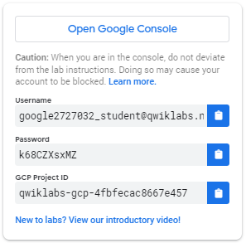

1. Copy the username, and then click **Open Google Console**. The lab spins up resources, and then opens another tab that shows the **Sign in** page.

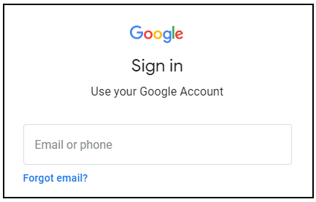

***Tip:*** Open the tabs in separate windows, side-by-side.

If you see the **Choose an account** page, click **Use Another Account**. 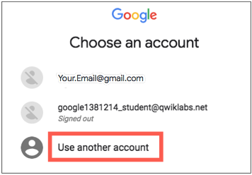

1. In the **Sign in** page, paste the username that you copied from the Connection Details panel. Then copy and paste the password.

***Important:*** You must use the credentials from the Connection Details panel. Do not use your Qwiklabs credentials. If you have your own Google Cloud account, do not use it for this lab (avoids incurring charges).

1. Click through the subsequent pages:
   * Accept the terms and conditions.
   * Do not add recovery options or two-factor authentication (because this is a temporary account).
   * Do not sign up for free trials.

After a few moments, the Cloud Console opens in this tab.

**Note:** You can view the menu with a list of Google Cloud Products and Services by clicking the **Navigation menu** at the top-left. 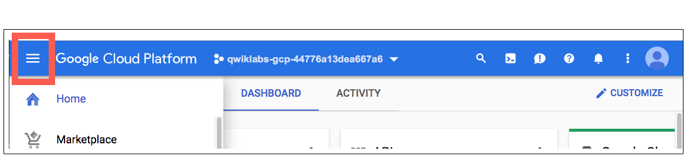

**Create a function**

In this step, you're going to create a cloud function using the console.

1. In the console, click the **Navigation menu** > **Cloud Functions**.

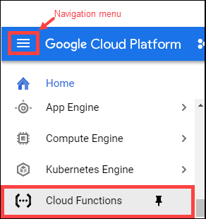

1. Click **Create function**.

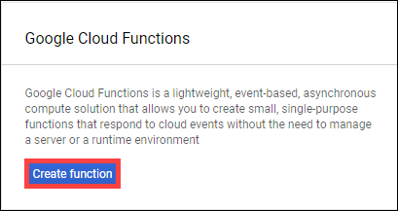

1. In the **Create function** dialog, enter the following values:

|  |  |
| --- | --- |
| **Field** | **Value** |
| Name | GCFunction |
| Memory allocated | Default |
| Trigger | HTTP trigger |
| Source code | Inline editor (use the default helloWorld function implementation already provided for index.js.) |

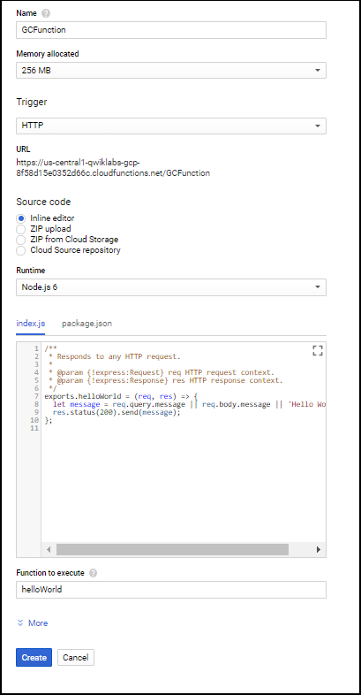

You deploy the function in the next section.

**Deploy the function**

Still in the **Create function** dialog, at the bottom, click **Create** to deploy the function.

After you click **Create**, the console redirects to the **Cloud Functions Overview** page.

While the function is being deployed, the icon next to it is a small spinner. When it's deployed, the spinner is a green check mark.

ab5cfeca3290b61f.png

Test Completed Task

Click **Check my progress** to verify your performed task. If you have completed the task successfully you will granted with an assessment score.

Deploy the function.

Check my progress

**Test the function**

Test the deployed function.

1. In the **Cloud Functions Overview** page, display the menu for your function, and click **Test function**.

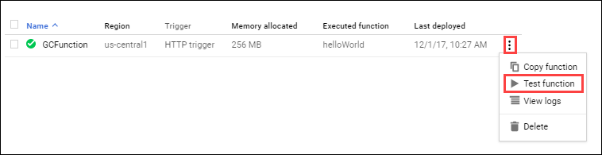

1. In the Triggering event field, enter the following text between the brackets {} and click **Test the function**.
2. "message":"Hello World!"

In the **Output** field, you should see the message Success: Hello World!

In the **Logs** field, a status code of **200** indicates success. (It may take a minute for the logs to appear.)

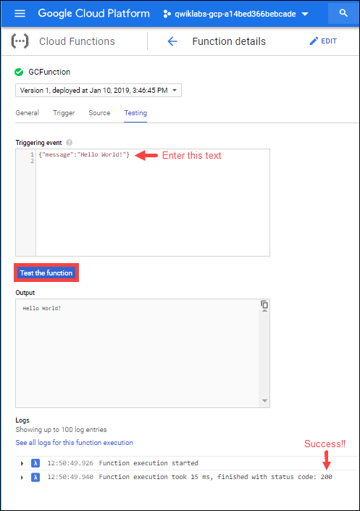

**View logs**

View logs from the Cloud Functions Overview page.

1. Click the blue arrow to go back to the **Cloud Functions Overview** page.

8917a2bfa4fb9502.png

1. Display the menu for your function, and click **View logs**.

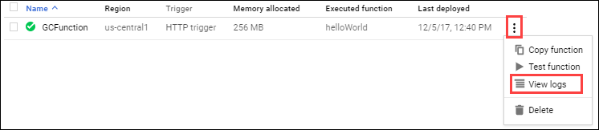

Example of the log history that displays:

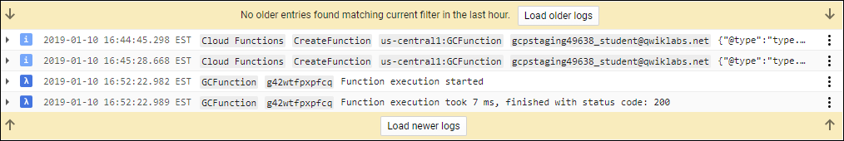

Your application is deployed, tested, and you can view the logs.

**Test your Understanding**

Below are multiple-choice questions to reinforce your understanding of this lab's concepts. Answer them to the best of your abilities.

Cloud Functions is a serverless execution environment for building and connecting cloud services.



True



False

Which type of trigger is bound while creating Cloud Function in the lab?



Cloud Storage



HTTP



Google Cloud Pub/Sub



Firebase

Submit

**Congratulations!**

This concludes the hands-on lab, [Cloud Functions: Qwik Start - Console](https://google.qwiklabs.com/catalog_lab/704). You used the Google Cloud console to create, deploy, and test a cloud function.